1. Make 2 directories in tmp directory

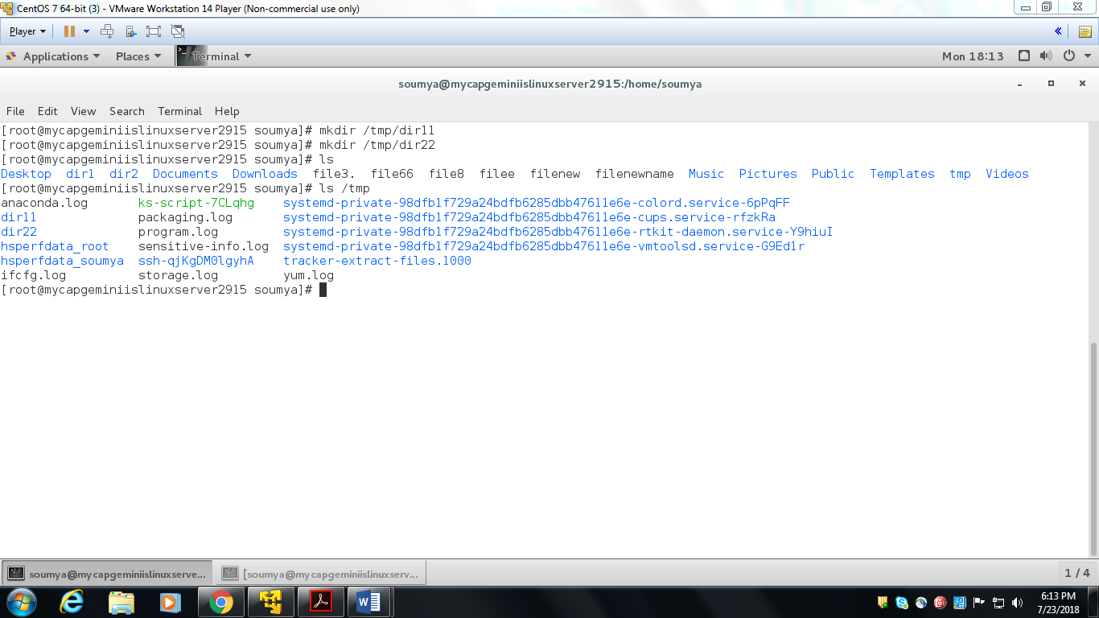

1. Create file in second directory to make it empty directory

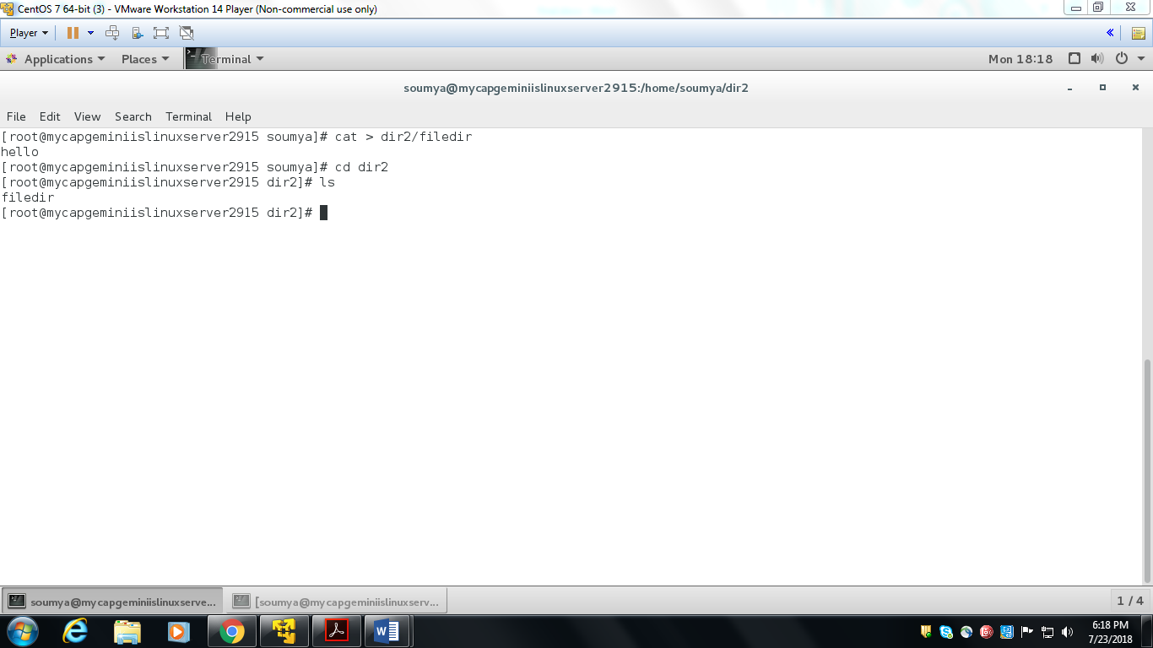

1. Create 3rd directory automatically missing parent directory

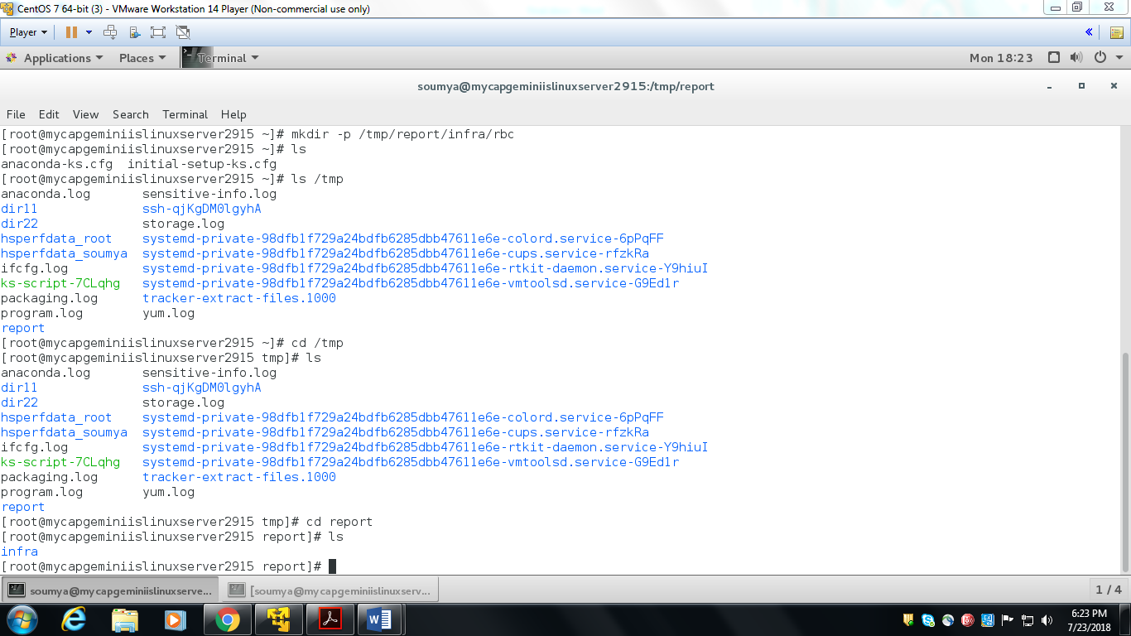

1. Rename first directory

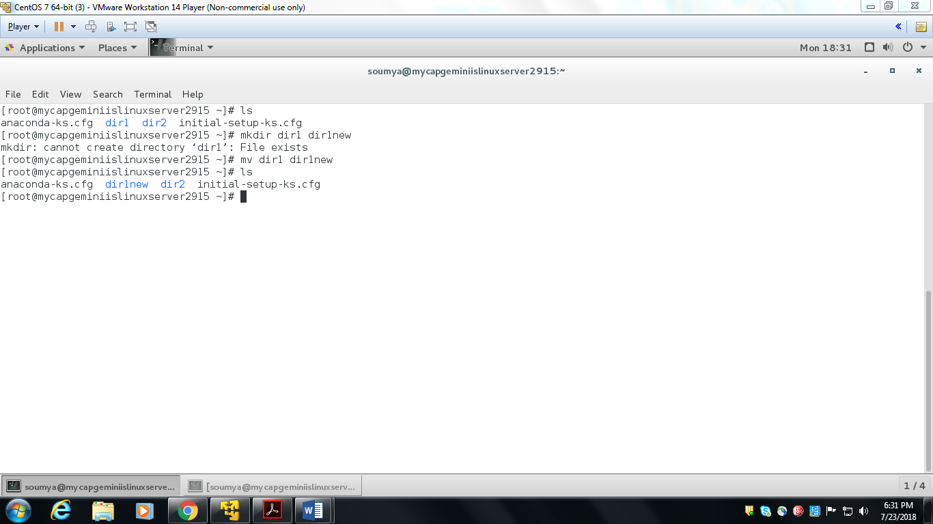

1. Move the rename directory to home directory

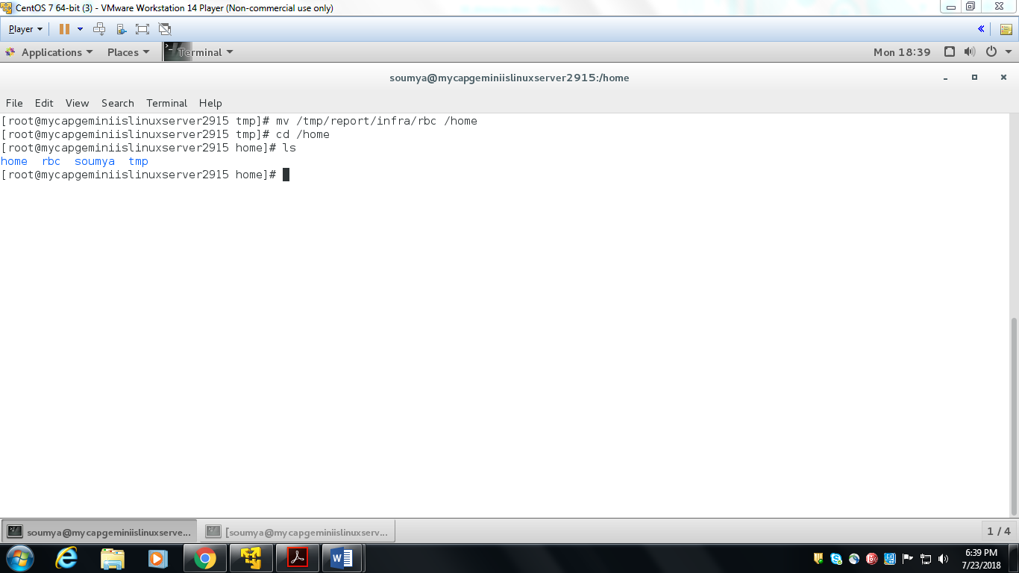

1. delete first empty directory in home directory

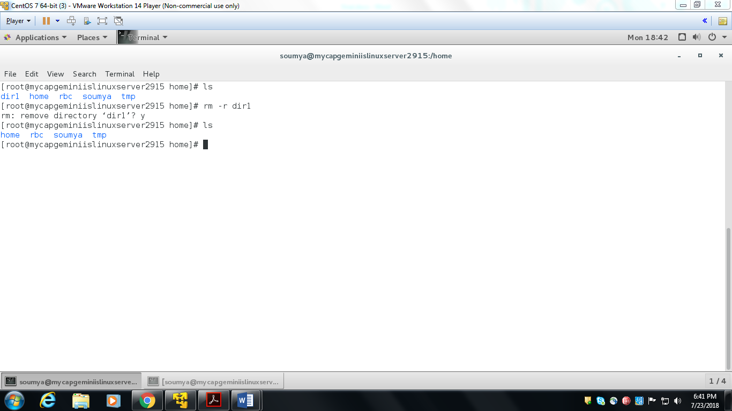

1. delete 2nd non-empty directory in /tmp/ directory

